FTP Protocol Analysis
A lab-based analysis of FTP protocol traffic to identify insecure data flows and attack indicators at the network level.
Established a baseline by capturing normal FTP sessions, analyzing control-channel commands (USER, PASS, RETR, STOR) and data-channel behavior. Conducted reconnaissance against the FTP service and analyzed scan traffic to identify enumeration and service discovery patterns.
Simulated FTP exploitation and monitored the activity using Suricata, correlating alerts with packet-level traffic to identify credential exposure, malicious command sequences, and indicators of compromise IoCs.

#lab

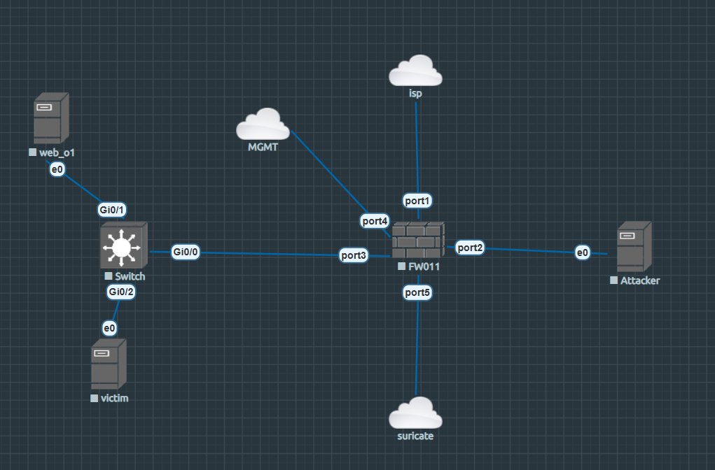
.

#ftp
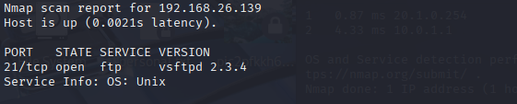
#nmap
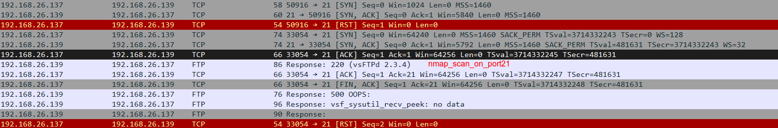
.

#nids
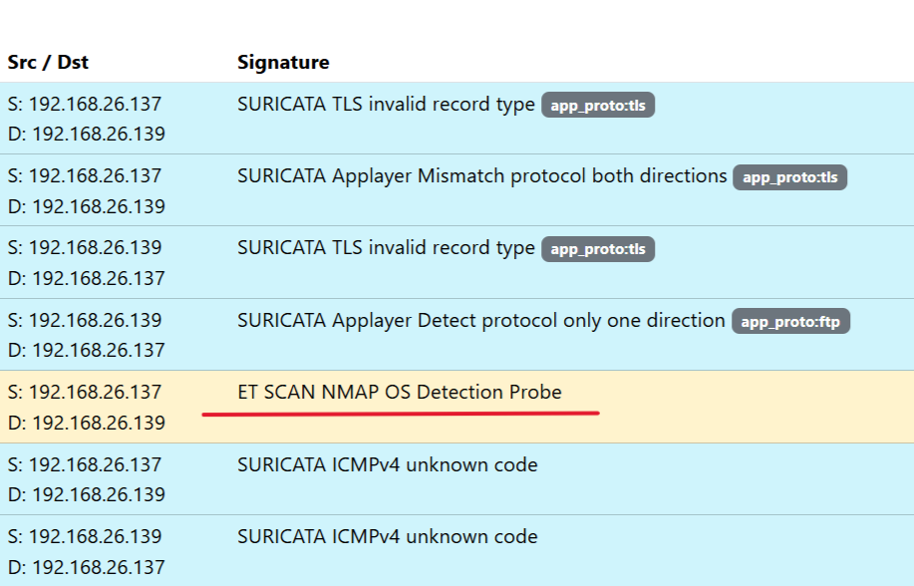
/

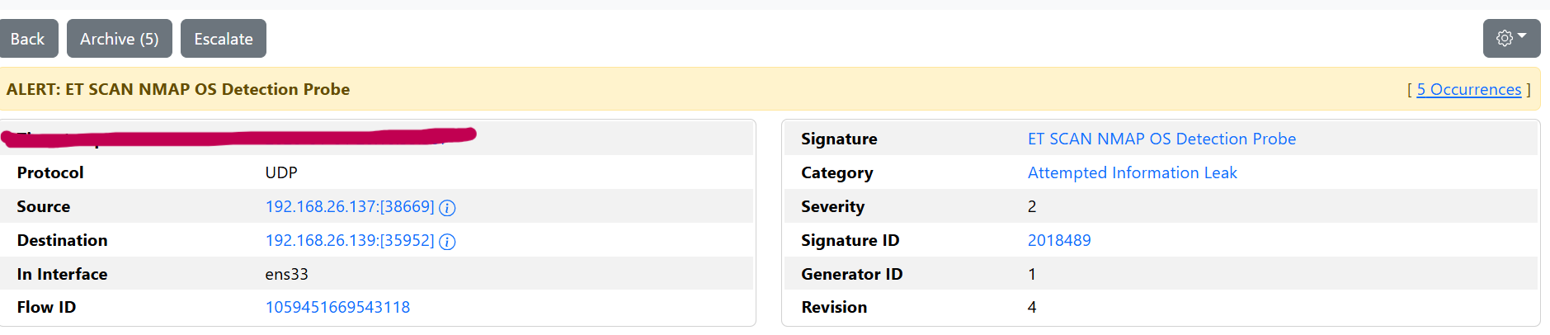
.
#Exploring FTP Vulnerability
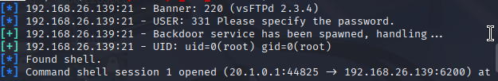

.
# Network packet analysis with wireshark
The concept of the attack on VSFTPD 2.3.4 is to trigger the malicious vsf_sysutil_extra(); function by sending a sequence of specific bytes on port 21, which, on successful execution, results in opening the backdoor on port 6200 of the system
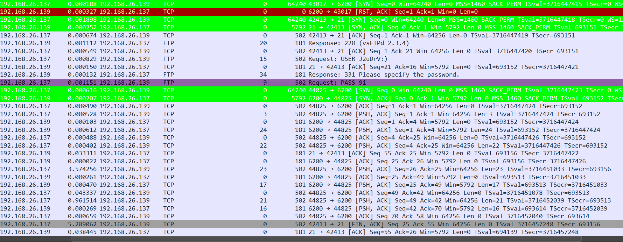

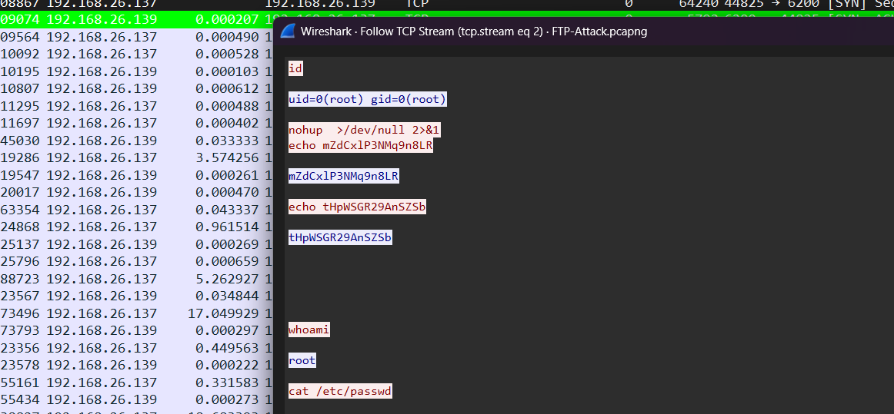
.

#nids
